1. Delete box select and ‘x’ key
2. Add Mesh Plane (shift –A)
3. Center Plane (ALT –G)
4. Bring up transform properties (n) set dimension 16x16 on x and y.
5. Go to property view, material proeryt and add a material
   1. Make shadeless bdy.data.materials[‘Material.001’].use_shadeless = **False**
   2. Options. UV Project set. bpy. data.materials[‘Material.001’].use_uv_project = True
6. Add texture of image (Open image) (UV Mapping)
7. Back in the object viewer : Tab Key (edit mode) and then U ‘Unwrap’
8. Texture View

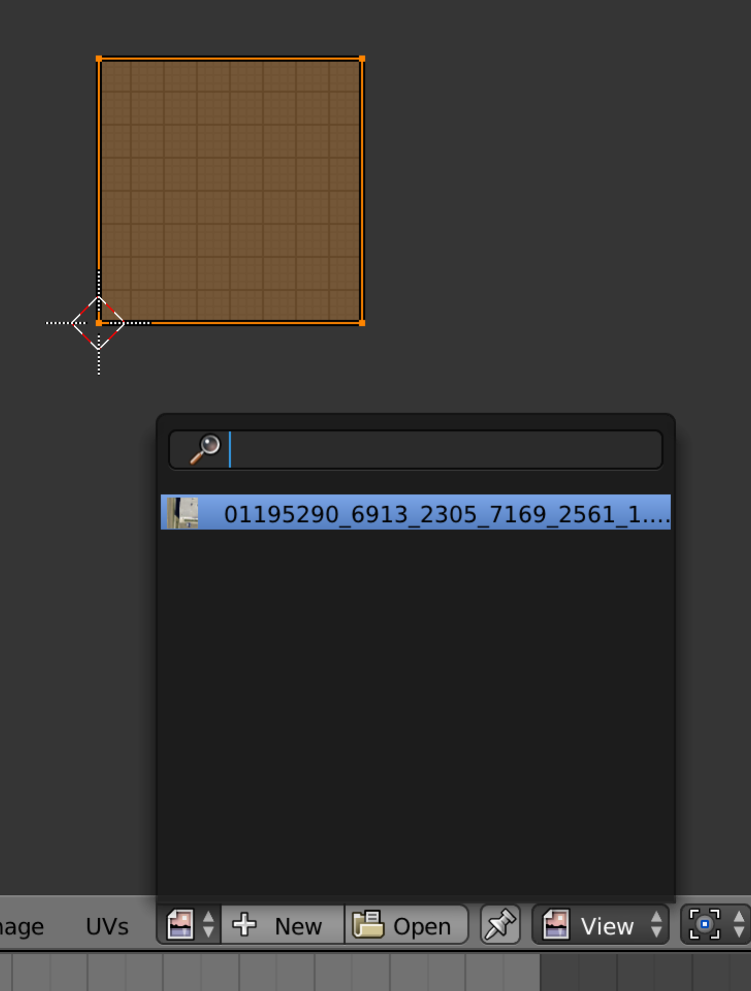

1. Move camera: select camera, Altr –R, Alt-G
2. Change the Z axis in transform property to 17.5.
3. Cameria Propertes: Shading/Subsurface and Shaing/Environ are False
   1. bpy.data.scenes[‘Scene’].render.resolution_y = 512, bypydata.scenes[‘Scene’].render.resolution_x = 512
   2. Aspect ratio is 1 to 1: data.scenes[‘Scene’].render.pixel_aspect y = 1 bpy.data.scenes[‘Scene’].render.pixel_aspect x = 1
4. Lamp: Set to Sun: bpy.data.lamps[‘Lamp’].type=’Sun’.
5. Turn off specular: bpy.data.lamps[‘Lamp’].use_specular=false
6. Lamp. Increase Sampling to 12 or 16.
7. Lamp. Soft Size to 2.5
8. Lamp. Adaptive Threshold to 0.601
9. Lamp. Energy to 1.5
10. Lamp. Sky = True (set)
11. Lamp.Turbidity = 3.5
12. Center Lamp and raise to 20 on Z (for now)
13. Scene Alpha more to ‘SKY’. Scene.render.alpha_mode=’SKY’
14. 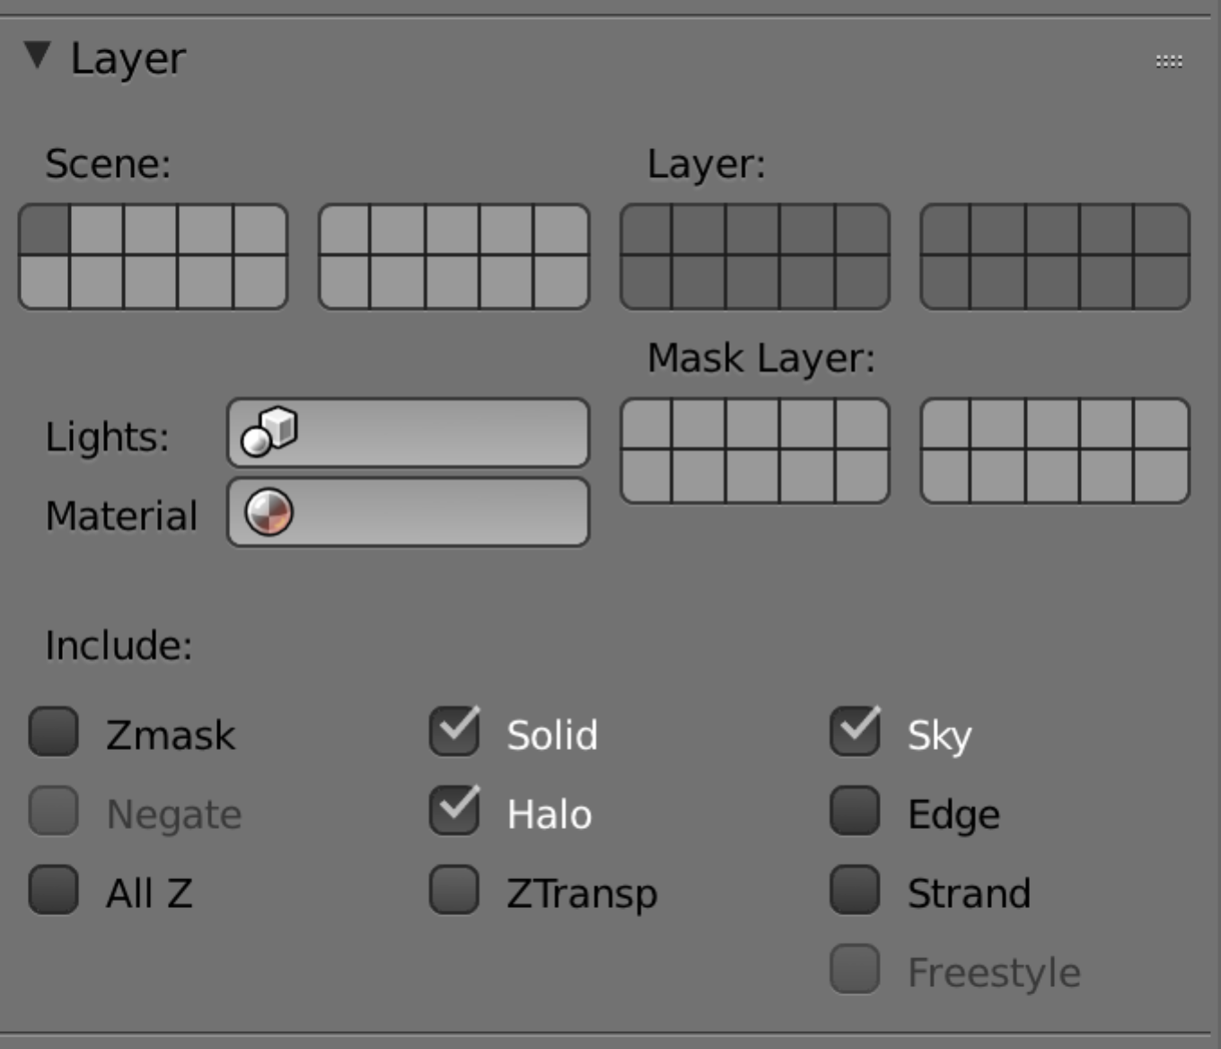
15. Soft Size to 2.5

Append Vehicle

Size appropriately. Locaition Z= 0

Material Mapping should be UV with a Flat projection.

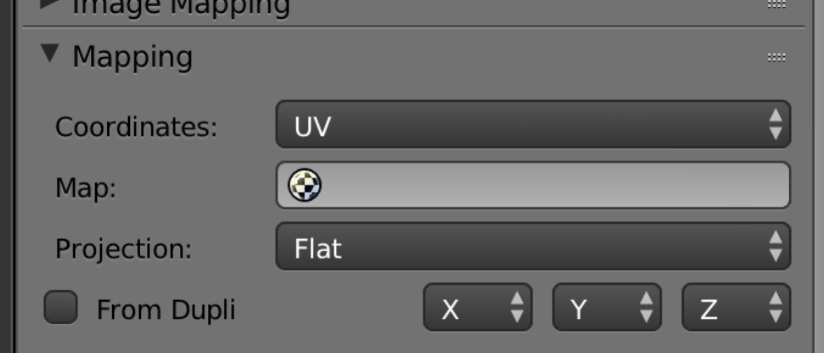

List of Questions:

1. Grainy of Car: Render with a certain grain affects the image as well as the car. Really want to just affect the car
2. Use the pictures of cars to make indistinguishable from model